Place Value within 50-Information
Children need to learn:
-to count forwards and backwards within 50
-to order numbers within 50
-to count in fives and tens
-that the digit 3 in 37 represents 3 tens and the digit 7 represents 7 ones

Activities to Choose From:
Ordering Numbers to 50 | See cut and stick activity sheet for ordering numbers from 0-50
Ordering Numbers to 50 | Cut up some squares of paper or use post-it notes. Children can practise writing 2 digit numbers that you say, like 34, 18, 29, 36, 50 and 47, for example. After these are written down, have your child cover his or her eyes before hiding the numbers in different places of the room. Have your child find the numbers and put them in order from smallest to largest or from largest to smallest.
Counting on and back within 50 | -Have your child practise writing some numbers to 50 on post it notes or squares of paper. Fold up the numbers and put them into a hat. Have your child pick a number out of the hat and then count either on or back for a few numbers. For example, count back from 27 or count on from 19. Your child may need to use a number grid when going into the next set of 10. See the number grid if needed.
Building Numbers to 50 | -See information sheet  -Place Value Mat
Match the words and representations | See Activity Sheet:  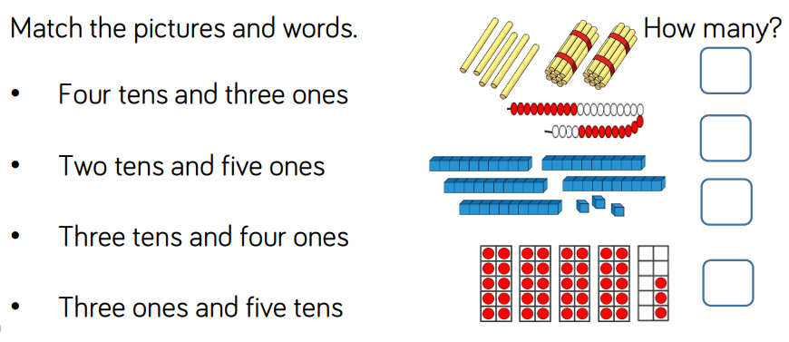
Counting in 5’s and 10’s | Use 5p coins or 10 p coins. Practise counting an amount of given coins. What can you think of that comes in groups of 5’s and 10’s. (5 toes on each foot, 10 ice-lollies in a box, for ex.)
Numbers from 1-50 Grid | Practise Writing numbers in order from 1-50. What patterns do you notice?

