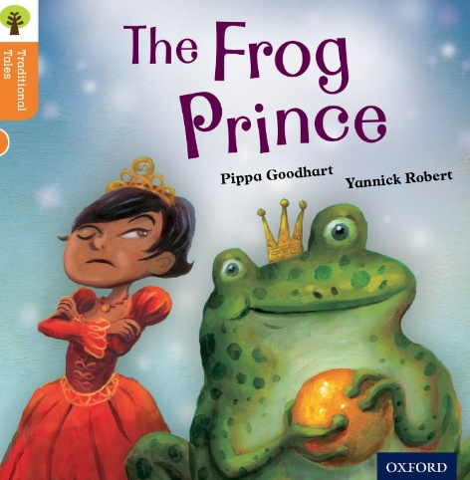
https://www.oxfordowl.co.uk/api/digital_books/1403.html
Reading Activity 3

Look through the book. How many words can you find with these phonemes in:
oo
ee

ou
ay

Can you find all the words ending in ‘ed’?

