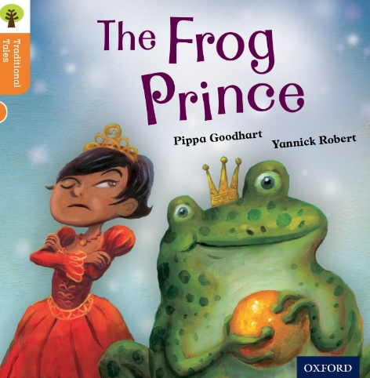<https://www.oxfordowl.co.uk/api/digital_books/1403.html>

Reading Activity 4

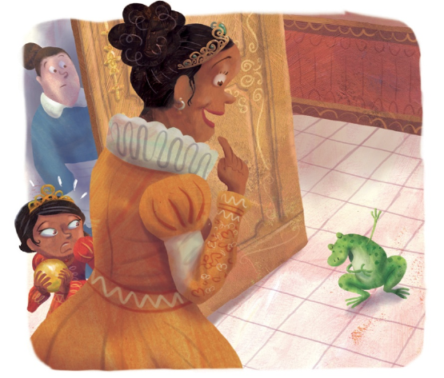

What might the Princess and the Frog say to each other in this picture?

