Topic: The Rights of the Child in Victorian Times

(Lessons 1-4 have been taught in class.)

Lesson 5 – Crime and Punishment

Learning Objective: to understand how children were treated by the justice system in the 19th century.

Background
Young people have always got into trouble with the law. What changes over time is how society deals with its young offenders.

Before Victorian times no distinction was made between criminals of any age. Accordingly, young children could be sent to an adult prison.

The Victorians were very worried about crime and its causes. Reformers were asking questions about how young people who had broken the law ought to be treated. They could see that locking children up with adult criminals was hardly likely to make them lead honest lives in the future. On the other hand, they believed firmly in stiff punishments. In 1854 Reformatory Schools were set up for offenders under 16 years old. These were very tough places, with harsh discipline enforced by frequent beatings. Young people were sent there for long sentences – usually several years. However, a young offender normally still began their sentence with a brief spell in an adult prison.

Begin by thinking about this question:
How are children treated nowadays if they do something wrong?
Examples: hitting another child; stealing some food; breaking someone’s property.

In which ways do you think this might have been different in the past? Why?

Now look at these copies of legal documents recording what happened to children who committed crimes. Once you have read them, try to answer the questions that follow:

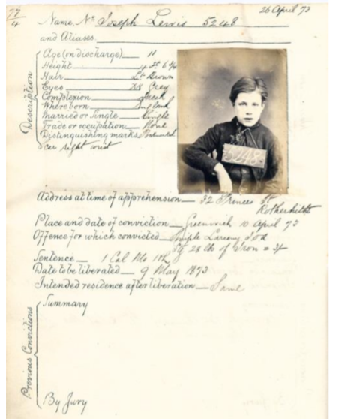

Transcript

26 April 73
Name No – Joseph Lewis 5248
and Aliases.___________________

Description:

Age (on discharge) _____ 11
Height _______________ 4ft 6 3/4
Hair _________________ Lt Brown
Eyes _________________Dk Grey
Complexion ___________ Fresh
Where Born ___________England
Married or Single _______Single
Trade or occupation _____None
Distinguishing marks _____Pockmarked Scar right wrist
Address at time of apprehension – 32 Princess St Rotherhithe
Place and date of conviction – Greenwich 10 April 73
Offence for which convicted – Simple Larceny for st[ealin]g 28lb of Iron = 3/-
Sentence – 1 Cal[endar] Mo[nth] H[ard] L[abour]
Date to be liberated – 9 May 1873
Intended residence after liberation – Same
Previous Convictions: Summary
By Jury

How old was Joseph and what offence did he commit? What was his punishment?
Why do think he might have been stealing? Do you think the punishment was appropriate?
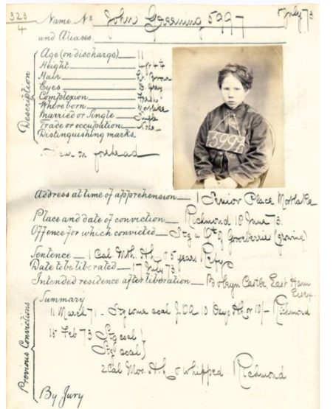

5 July 73
Name No – John Greening 5997 and Aliases _______________
Description: Age (on discharge) ______11 Height __________________4ft 4 1/4 Hair ___________________ Lt Brown Eyes ___________________D Grey Complexion _____________Fresh Where Born _____________Mortlake Married or Single _________Single Trade or occupation ______ None Distinguishing marks – Scar on forehead
Address at time of apprehension – 1 Senior Place, Mortlake
Place and date of conviction – Richmond 10 June 73
Offence for which convicted – St[ealin]g a Q[uar]t[er] of Goosberries (growing)
Sentence – 1 Cal[endar] M[on]th H[ard] L[abour] & 5 years Ref[ormitor]y
Date to be liberated – 17 Jult 73
Indended residence after liberation – Boleyn Castle, East Ham, Essex
Previous Convictions:
Summary
11 March 71 – St[ealin]g coal J.O.A. 10 Days H[ard] L[abour] or 10/- Richmond
15 Feb 73 St[ealin]g coal
St[ealin]g coal
2 cal[endar] mo[nth]s H[ard] L[abour] & whipped Richmond
By Jury
Remarks, antecedents &c
Rab. sent 5-April 73

How old was John and what offence did he commit?
John’s punishment was in 2 parts – what do you think was the point of sending him to prison AND sending him to the Reformatory? Do you think his punishment was appropriate?
Transportation
Another form of Victorian punishment was transportation – this meant sending the criminal to a penal colony in a different country.
This list shows children being sent on a ship called the Elphinstone to Van Diemens Land (now Tasmania, in Australia) in 1842.
Look at the list, then try to answer the questions:

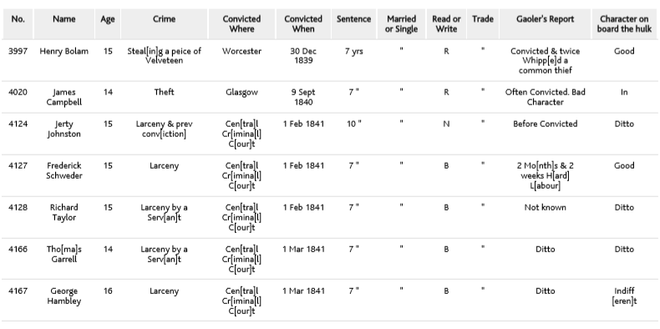
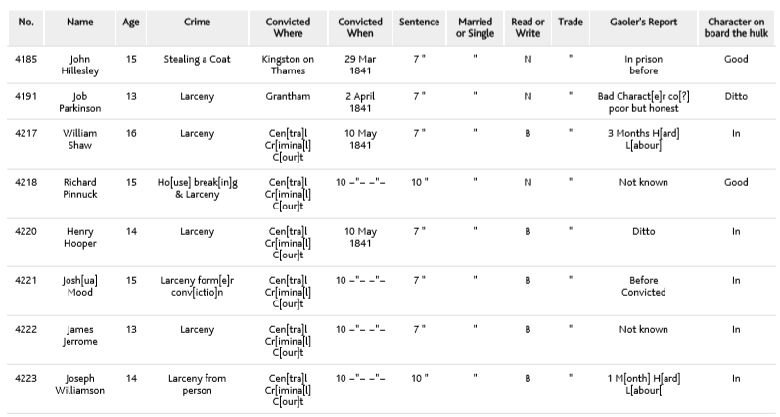
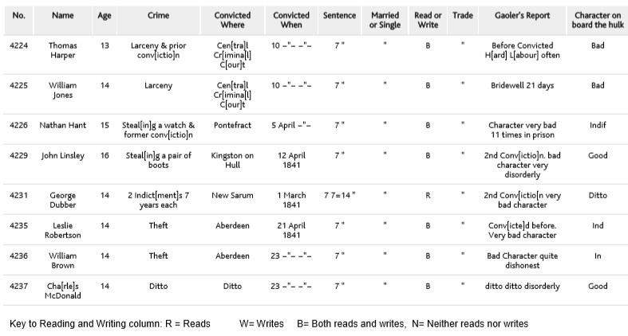

- Can you work out the average age of the convicts?
- What kinds of crimes were they guilty of?
- Can you think why they might have committed these crimes?
- How long is the average sentence?
- Do you think they were allowed to come home at the end of their sentence?

You can watch these clips for more information about how Victorian children were treated when they committed a crime:

https://www.bbc.co.uk/teach/class-clips-video/history-victorian/zn4pbdm
https://www.bbc.co.uk/teach/class-clips-video/history-social-studies-ks2-ks3-gcse-victorian-prison-punishments-john-smith/z4x4qp3
https://www.bbc.co.uk/teach/class-clips-video/history-social-studies-ks2-ks3-gcse-victorian-james-fleming/zjnw6v4

Your task:

LO: I can give my opinion about punishments in the past.

Writing in full sentences, answer these questions as fully as you can using evidence from the historical documents:
1. Here are 4 possible aims for the punishment of crime:
  - Deter others from committing crimes
  - Punish the offender
  - Reform the offender (change their behaviour) so they won’t do it again
  - Protect the public
Which of these aims were being met by these sentences on Victorian children? Put them in order, from1 to 4, with 1 being the most important, and explain your reasons.
2. What do you think would happen to Joseph Lewis and John Greening if they committed the same crime again? Explain your answer.
3. How do you think these children would be treated nowadays?
4. Imagine you are a Victorian child – you have been caught stealing food because you were hungry. You are found guilty and sentenced to transportation to Australia. Write a paragraph explaining how you feel and whether or not you think the punishment is fair.

Lesson 6 – Children’s rights today

At Martin we often talk about the UN Declaration on the Rights of the Child. In this topic we have found out what rights children had (and didn’t have) during the 19th century, and how some people tried to improve children’s live (by starting schools, campaigning and changing the law so that children were protected).

Nowadays, children’s rights are protected in many countries, but not all. We would like you to find out about situations around the world where children’s rights are not respected and where children need more protection.

Think about the following examples:
- Children who have to work to earn a living (factories, rag-picking)
- Children who have no access to education
- Children who have no or little access to clean water and healthy food
- Children who are forced to fight as soldiers

Look at some of the following websites to find out more.
Use the information you find to create a poster, Powerpoint presentation or report about children’s rights in the 21st century.
You could also make a comparison between what you know about children’s lives in the 19th century and children’s lives in the 21st century.

https://www.bbc.co.uk/teach/class-clips-video/child-labour-on-cocoa-plantations-in-ghana-part-1/zff347h

https://www.oxfam.org.uk/what-we-do/the-impact-of-our-work/pakistan-girls-education

https://www.unicef.org.au/blog/stories/august-2016/child-labour-stories
Examples of children working

https://www.antislavery.org/slavery-today/child-slavery/?gclid=EAIaIQobChMIl-ea1KqT6AIVWeDtCh0dKAD-EAAYASAAEgIXsPD_BwE
The ‘Our Impact’ section has stories of children and adults who escaped modern slavery.

https://www.childhope.org.uk/stories/
Projects helping children who have no access to education, are victims of exploitation and poverty.

https://globalmarch.org/

http://www.bbc.co.uk/worldservice/people/features/childrensrights/childrenofconflict/soldier.shtml

https://www.warchild.org.uk/what-we-do/protection/risks-for-child-soldiers-are-huge-and-the-effects-can-last-a-lifetime

