Literacy – Nonsense Poems
This week will cover the key stage 1 spoken English, reading and writing national curriculum objectives.
Session 1
- Read poem – On the Ning Nang Nong What do they notice? – rhyming and it does not make sense as it is a nonsense poem
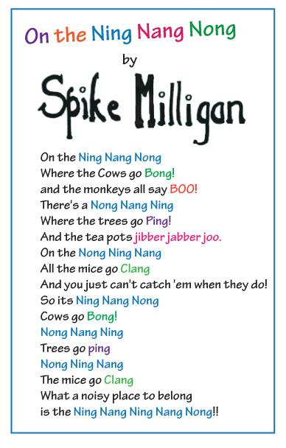
You could share a few facts about the poet.
Spike Milligan
• Spike Milligan was a very famous poet.
• He wrote mainly for children.
• His poems were very silly and known as literary nonsense.
• On the Ning Nang Nong was his most famous poem, about an imaginary land.
- If you want you can watch this video that explains about nonsense poems:
https://www.bbc.co.uk/bitesize/topics/z4mmn39/articles/zgbyw6f
- Using the copy of the poem get your child to look more closely at it.
Look at the silly words – what do they mean? Can you explain what is happening? Does it matter? What is your favourite part?
Encourage your child to highlight the rhyming words and repetition.
- Video showing what a rhyme is
https://www.bbc.co.uk/bitesize/topics/zjhhvcw/articles/zqjgrdm
Play some rhyming games e.g.
Match up rhyming pairs activity – first match up the pairs then you could play a memory game of pairs.
Competition in one minute – How many words can they come up with that rhyme with e.g. rat. Children write down own words.
Go on a hunt around the house – can you find something that rhymes with mat etc?
Session 2
- Watch video of Spike Milligan performing the poem On the Ning Nang Nong
https://www.bbc.co.uk/bitesize/clips/zgnxpv4
- Tell your child that they will be learning and performing the poem to family. You could record it if you wish and show to other family members. Please feel free to email your child’s teacher to tell us how the performance went.
Watch video telling children how they can memorize poem if you wish.
https://www.bbc.co.uk/bitesize/topics/zjhhvcw/articles/zsgvjty
- Get creative!
If you have musical instruments, they could use these, or they could make their own using items around the home e.g. pan and wooden spoon – drums, rice in a container – shaker
T They could make up actions alongside the poem and use scarves and ribbons in their performance.
Change their voice for different parts of the poem.
Change their location in their house.
Children plan out what they are going to do when performing it
Session 3
- Children continue to memorise and work on performance
- Perform and record if wish to share with other family members. Send an email if you wish to your child’s teacher saying how the eprformance went.

Session 4
- Introduce other nonsense poems
Michael Rosen reads a variety of his own nonsense poems
https://www.youtube.com/watch?v=kt28bVw0xYw
- How to make own nonsense poem
Children to find nonsense words that rhyme with words from the model text:
Tail
Wig
Dog
Cat
Boo
Bong
Ping
Clang
Use these to write own poem, using same structure as original, only changing the rhyming words and animals. See word document to help.
Session 5
Children complete writing and drawing illustrations to go alongside the poem and perform for family and carers if they wish.
Extra - Other links to nonsense poems
Michael Rosen has a great youtube channel
https://www.youtube.com/watch?v=gJ-28zrYq-M
More nonsense poems
https://www.youtube.com/channel/UC7D-mXO4kk-XWvH6lBXdrPw
Other Michael Rosen poems
More Nonsense Poems
An Alphabet – Edward Lear
Jabberwocky – Lewis Carrol

