Rainforests Questions – the answers

A) Where are the world’s rainforests?

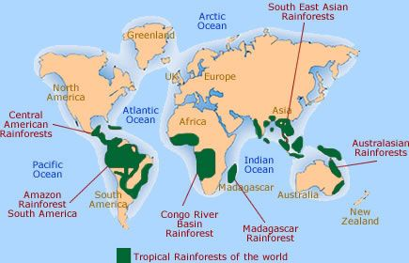

You may also have found temperate rainforests in North America (northern Pacific coast), coast of Chile in South America, south-eastern Australia, New Zealand, Japan.

You should see that the tropical rainforests are all found close to the Equator, between the Tropics of Cancer and Capricorn.

B) Rainforest climate

1. January, March and April
2. Range of rainfall totals is around 240mm. Temperature range is 2-3 degrees.
3. There is very little variation in temperature across the year, whereas there are 2 clear seasons for rainfall – a very rainy season (December to May) and a less rainy (but still quite rainy!) season from June to November.
4. Although the UK’s rainfall pattern is similar in shape to the rainforest, the quantity of rain is much less (the UK’s rainiest month has half the rain of the rainforest’s rainiest month). The temperature range for the UK on this chart is around 15 degrees – a much greater range than in the rain forest, and generally much cooler too.
5. Warmth and water are essential elements in plant growth, so it is no surprise that a location like the rainforest, which has high temperatures all year round and lots of rain, has a huge variety and density of plants and trees (some of which grow to enormous sizes). In the UK, a colder season means trees and plants are dormant (not growing) for many months, so they grow more slowly.

C) Ecosystem – main information contained in PowerPoint.

