Maths w/c 30th March 2020
Hello,
Hope you are all doing well and adapting to school from home!
Please continue to practise your timetables, using Timestables Rockstars if you have your logins (logins should be with you if not already, then over the coming days).
This week our focus in maths will be on telling the time and answering time/ timetable questions. Below I have laid out activities for the week including arithmetic questions and a mad maths. Choose how you want to arrange your week of maths- you may want to do some arithmetic questions each day as a starter and then have a go at the time/ timetable questions and then do mad maths one day. These are not 5 separate lessons, but rather work to complete throughout the week so work your way through the way that works for you.
I have also suggested some practical activities that you could do in addition throughout the week exploring time in different ways.
There are then some challenges at the bottom to really test yourself!
Answers and workings out have been uploaded in another document.
Any questions, please don’t hesitate to email!

Arithmetic
1.) 39 + 673 =
2.) 9/11 – 4/11
3.) 2 x 45 =
4.) 838 ÷ 1 =
5.) 5 x 4 x 10 =
6.) 99 ÷ 11=
7.) 7,064 – 502 =
8.) 6² + 10 =
9.) 56.38 + 24.7 =
10.) ______ - 10 = 298
11.) 270 ÷ 3 =
12.) 5,400 ÷ 9 =
13.) 60 ÷ 15 =
14.) ________=5,776 – 855
15.) 3,050,020 = 3,000,000 + __________ + 20
16.) 10 – 5.4 =
17.) 5/7 + 3/21 =
18.) 0.1 ÷ 100 =
19.) ¾ of 1,000 =
20.) 785 x 23 =
21.) 23% of 1,200 =
22.) 645 ÷ 43 =
23.) 28 x 0.5 =
24.) 1/2 + 1/5 =
25.) 1 ¾ + ¾ =
26.) 6 – 5.738 =
27.) 3.9 x 30 =
28.) 1 1/15 – 2/5 =
29.) 5413 x 86 =
30.) 99% of 200
31.) ¼ ÷ 2 =
32.) 9² – 36 ÷ 9 =
33.) 1 ½ x 40 =
34.) 28% of 650 =
35.) 4 2/3 – 1 6/7 =
36.) 8827 ÷ 97 =

Mad maths
1.) Multiply nine hundred and twenty six by eighteen.
2.) If a choir of 12 members earn £2940 for a concert, how much will each member get?
3.) Add 63.52 and 17.29 and subtract the result from one hundred.
4.) Which is greater, four tenths or 0.04?
5.) What is 100 greater than four thousand, three hundred and eight.
6.) List all the factors of 72
7.) The dog Roxi has 7 times as many treats as the dog Bonnie. Bonnie has 8 treats. How many does Roxi have?
8.) What is greater 0.42 mulitplied by 10 or 420 divided by 1000?
9.). Multiply 0.85 by 1000
10.) Put these measurements in ascending order 7.8m 7800cm 780mm.
11.) A regular octogon has one side measuring 4.2cm. What is the total perimeter?
12.) I start my journey at 12:32 and it takes me 1hour 12 mins to get to my destination. What time will it be when I arrive.
13.) The cinema costs £3.50 for an adult and £2.20 for a child. How much will it cost for two adults and three children?
14.) For every point Man UTD get, Chelsea get 3. By the end of the season, Chelsea have 42 points. How many do Man Utd have?
15.) A shop is having a sale with 35% off. A TV was £990. How much is it now?

Time

Some quick fire times facts to check!

How many months in a year?
How many days does each month have?
How many seconds in a minute?
How many minutes in an hour?
Hours in a day?
Hours in a week?
Weeks in a fortnight?
7:15 am =
20 past midnight =
12:50pm =
4:25 pm =

write these times in 12 hour clock.
11:15 =
13:20 =
07:45 =
20:20 =
00:15 =
If you need practise reading the time in analogue, digital or converting between 12 and 24 hour clocks, please use the following links on my maths (Username- martinprimary Password- number)
https://app.mymaths.co.uk/5935-lesson/telling-the-time-quarter-to-past
https://app.mymaths.co.uk/5936-lesson/telling-the-time-to-5-mins
https://app.mymaths.co.uk/288-lesson/telling-the-time-2
https://app.mymaths.co.uk/1751-lesson/time-conversions-2

Time problems
The best way to solve time problems is to draw out a timeline. Think about if the question is asking you to count on in time (does it giving you a starting point and you have to count forward), do you need to count backwards (the question gives you the time something ends and you need to work out what time it should start), or do you need to work out how long an activity lasts for (you are given the starting and ending time).

E.g-
Coutning forward-
Sally left her house at 07:30. She walked 17 mins to the bus stop and then her bus journey was 35 mins. At what time does she arrive at her destination?

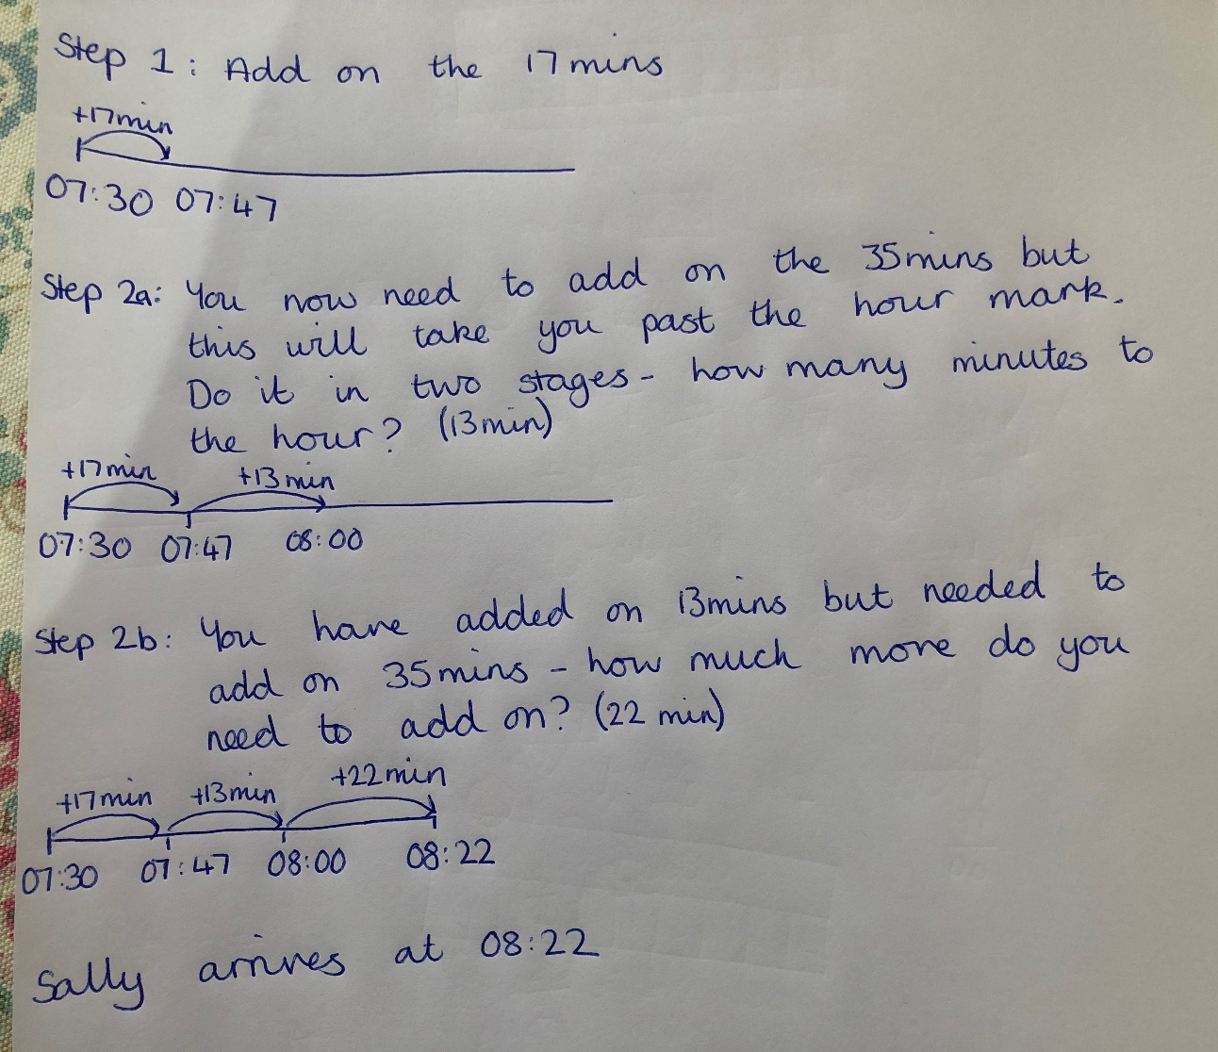

Counting back-
Sally's flight is at 13: 00. She needs to be at the airport two hours before her flight. She takes a 45 min train to the airport and it takes her 17 mins to get to the train station. What time should she leave her house?

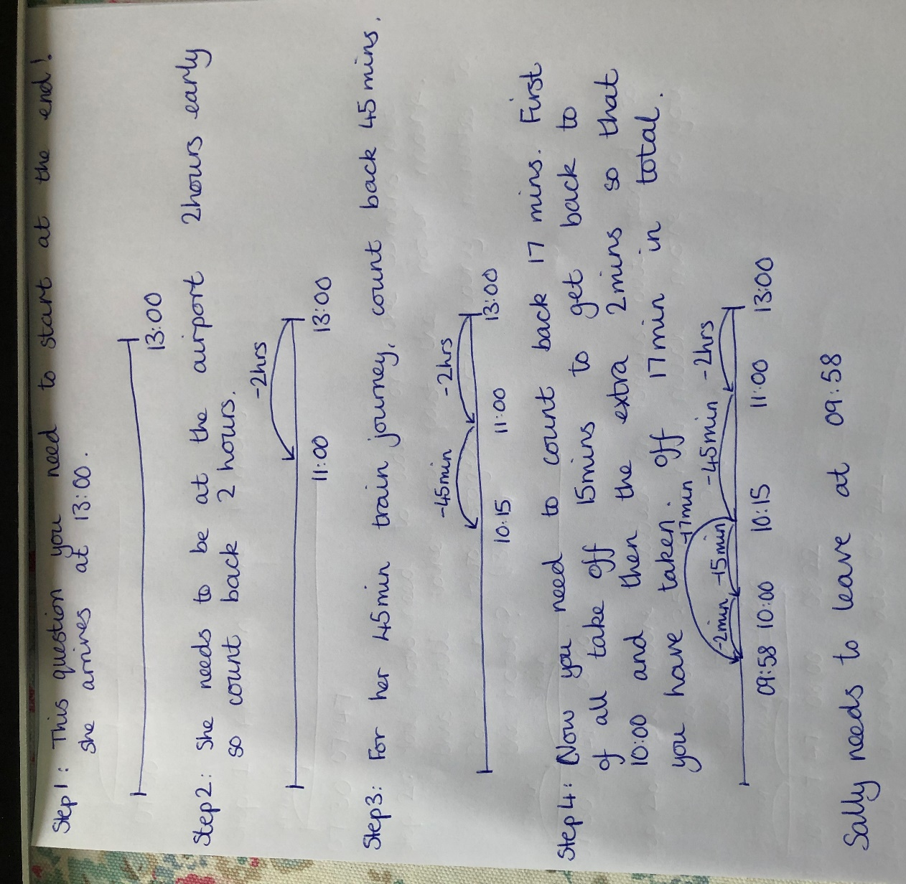

Working out how long-
Ben started painting his room at 08:30. He finished at 15:10. For how long was he painting?

Now have a go at answering the following questions (see answers and workings on answers sheet)
Time questions
1.) Joe leaves his house at 15:15. He walks to the bus stop which takes 13 mins. He waits for the bus for 12 mins and then the bus journey takes 40 mins. What time does he arrive at his destination?
2.) Sally leaves her house at 9:40. She goes to the shops, has a doctors appointment, picks something up from the Post Office and takes her car to the mechanic. She returns home at 14:23. How long has she been out of her house for?
3.) A flight is due to take off at 09:45 but it is delayed by 2 hours and 30 mins. The flight is 3 hours 40 mins. At what time will it now arrive?
4.) Kate needs to catch a train at 14:36. She wants to be at the station 10 minutes early. It takes her 35 mins to get to the station. What time should she leave her house?
5.) Hannah finishes work at 17:30. James finished 18 minutes before her and Lilly finished 26 minutes before James. What time did Lilly finish at?
6.) Jane was due at her friend’s house at 16:30. She was 10 minutes late leaving her house and then she got stuck in traffic so her journey took 47 mins. She was meant to leave her house at 16:00. How late was she for her friend?
7.) Jane is cooking a chicken. For every kilogram she needs to cook it for 30 mins. Her chicken weighs 4.5kg. If she puts her chicken in at 13:00, at what time will it come out?

Reading timetables
Below is a timetable for the opening times for the London Eye and questions about the information. I have modelled how to answer each question, then have a go at answering the questions about the bus timetable in your exercise book. Remember to draw out a timeline to help you.
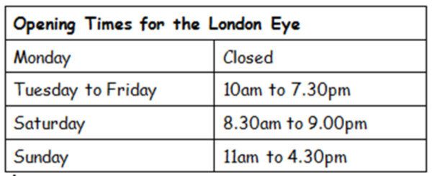

1.) For how long is the London Eye open for on a Sunday?

2.) If I arrive at the London Eye at 17:48 on a Wednesday, how long until it closes?

3.) I get a train to London from Reading on Tuesday morning. My train leaves Reading at 08:30 and takes 87 minutes to London. How long do I have to wait from my arrival until the Eye opens?

Now have a go at answering the questions about the Olympic Stadium Bus Service time table below and then have a go at the challenge of the Number 83 bus timetable.

Olympic Stadium Bus Service B
(The column on the left hand side shows the name of the bus stop. The right hand column shows the time the bus gets to/ leaves each station).
Stratford Bus Station | 07.10
Stratford High Street | 07.35
Pudding Mill Lane | 07.55
Old Ford | 08.04
Hackney Wick | 08.22
Olympic Stadium | 08.39
Olympic Aquatic Centre | 09.09

1.) How long does it take the bus to travel from Stratford Bus Station to travel to
a) Stratford High Street
b) Old Ford
c) Olympic Stadium
2.) How long does it take the bus to get from the first stop to the last?
3.) I arrive at Hakney Wick at 07:42. How long do I have to wait for the bus?
4.) The bus is held for 42 mins at Stratford High Street. What time does it now leave?
5.) I will be getting the bus from Pudding Mill Lane. It is a 41 minute walk from my house, I want to get a cup of tea from a café which will take 7 mins and I want to be there ten minutes early. What time should I leave my house?

83 Bus timetable
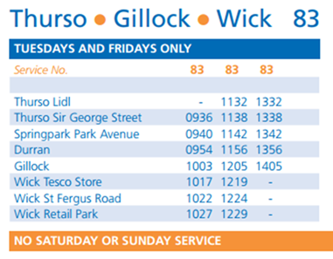

1.) If I am at Thurso Lidl, what is the earliest time I can get to Gillock?
2.) a. What is the latest bus time from Thurso Lidl to Wick Retail park?
b. How long does it take?
3.) How long does it take the 0936 from Thurso Sir George St to get to Gillock?
4.) I get to Durran bus stop at 10:35. How long do I have to wait for the next bus to Gillock?
5.) Which route takes longer, the 11:32 from Thurso Lidli to Durran or the 10:03 from Gillock to Wick Retail Park?
6.) I need to be at Durran for 11:50. What bus should I get from Thurso Sir George Street?
7.) What time does the last bus leave from Gillock on a Wednesday?

Extra activities:

1.) Estimate the time! (A game to play in pairs or small groups)
Can you guess when a certain amount of time has passed? You will need a timer for this game (most phones have timers or you can find one on google). Challenge your partner to call out when they think 10 seconds, 20 seconds etc has passed. If you are playing in a group- who can get closest to 10 seconds?

2.) How many times?
On a digital 24 hour clock, at certain times, all the digits are consecutive (in counting order). You can count forwards or backwards.
For example, 1:23 or 5:43.
How many times like this are there between midnight and 7:00?
How many are there between 7:00 and midday?
How many are there between midday and midnight?

3.) Make a sun dial!
Sundials are the oldest known instruments for telling time. The surface of a sundial has markings for each hour of daylight. As the Sun moves across the sky, another part of the sundial casts a shadow on these markings. The position of the shadow shows what time it is.

There are lots of suggestions/ printouts available on the internet with suggestions for doing this, but a very simple way to make a sun dial:

Equipment:
- Paper plate (or card/ paper cut into a circle)
- Pencil
- Bluetac/ plasticine/ cellotape to secure pencil (not essential but makes it easier!)
Instructions:
-Write the numbers 1 to 12 at equal distances on the back of the plate/ cut out circle (like the face of a clock).
- Make a hole in the middle and insert a pencil. Fix it with blue tac/ plasticine/ cellotape if available. - - Place the sundial on a sunny place. Rotate the sundial so that the shadow of the pencil falls to point to the current hour of the day.
- Keep checking your sundial throughout the day to see the shadow move around the clock face!

4.) TV schedule
Rather than just watching the TV- question the timings!
-How long do different programmes last?
- How much of a programme is advert breaks? Can you work this out as a fraction? A percentage?
-What TV show lasts the longest in a day?
-Look at the TV listings for BBC over a day- how many hours are programmes on about food, travel, nature, news, soaps etc…
- Can you make your own TV listings for your ideal day of TV?

Challenges

1.) Wonky Watches
Mandeep's watch loses two minutes every hour.
Adam's watch gains one minute every hour.
They both set their watches from the radio at 6:00 a.m. then start their journeys to the airport. When they arrive (at the same time) their watches are 10 minutes apart.
At what time (the real time) did they arrive at the airport?

2.) Norrie’s buildings
Norrie is watching the aircraft warning lights on the tops of some tall buildings in the city. He sees two lights flash at the same time, then one of them flashes every 4 th second, and the other flashes every 5 th second.
How many times do they flash together during a whole minute?
Norrie then watched a third light. He saw it flash at the same time as the other two, then flash every 7 th second. How many minutes before this light again flashes at exactly the same time as the other two?

